Chapter 13, Problem 15.

Find the Norton equivalent for the circuit in Fig. 13.84 at terminals a-b.

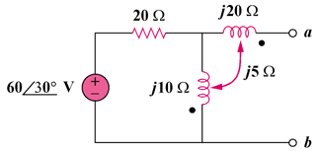

100∠30˚ V

Figure 13.84
For Prob. 13.15.

